

Statement of Work for
JDE Automation Test Services

Submitted to: CEI Services
Prepared by: LTM Ltd.

Submission Date: Feb 14th, 2026
Table of Contents

1. Introduction 3
2.3.1 3
2.3.2 1.1 Document Overview 3
2.3.3 1.2 Point of Contact 3
2.3.4 1.3 Background 3
2.3.5 2. Scope of Work for Test Automation 4
2.3.6 2.1 Out of scope 4
2.4 Development Execution Strategy – Sprint Definition, MVP and complexity 5
2.4.1 Definitions of Script complexity 5
2.4.2 Guidelines for Priorities 6
2.5 Phases, Activities and Deliverables 6
2.6 Pre- requisites and Environment Setup for Tricentis Testing tool 7
2.6.1 Activities owned by CEI 7
2.6.2 Activities owned by LTM 7
2.6.3 2.6 Project Timeline 7
2.6.4 2.8 Project Reporting 8
2.6.5 2.9 RACI 8
2.10 Assumptions 9
2.11 Dependencies 9
2.12 Commercials 9
2.13 Payment Milestone 10
2.6.6 Terms and Conditions 10
2.6.7 Annexure 1: CEI Services Compliance 12
2.6.8 Annexure 2: Scope Change 13
2.6.9 Annexure 3: Tricentis General Terms of Use 14

Introduction

1.1 Document Overview
This statement of work (“SOW”) is entered by and between CEI Services Management Partnership, L.P. (“CEI” or “Customer”), and LTM. ( “Provider”). The SOW defines the services to be undertaken and respective roles and responsibilities of the provider during the term of this SOW. The start date for this SOW is April 1, and shall continue through March 31 2027 unless otherwise terminated in accordance with Master Services Agreement (MSA), effective Jun 25th, 2025. This document states the work scope, service location, approach and associated charges to execute the services.

LTM is delighted to be part of this program and would show high commitment levels to enhance our partnership standing with CEI services.

The objective of this document is to detail the “Statement of Work” as part of this engagement at CEI Services.

1.2 Point of Contact
Any queries arising out of this document need to be addressed to below mentioned.
Primary Response Contact
Name | Jibat Sankar De Sarkar
Organization | LTM
Designation | Principal Director
Email | Jibat.Sarkar@LTM.com
Cell Phone | +1 (440) 391 9087

Background
​
LTM plans to automate CEI's JDE testing by delivering 264 automated test scripts, with an additional 25% effort allocated for medium- and high-complexity scripts. The overall script mix comprises 15% simple, 45% medium, and 40% complex scripts, to be delivered across 10 sprints of two weeks each

This Statement of Work outlines the scope of the engagement and the commercial terms and conditions.

Scope of Work for Test Automation

- Setup and configuration of Tosca environments on VMs
- Deliver 264 automated test scripts and an additional 25% for medium and high complexity scripts,(15% simple, 45% medium, and 40% complex scripts in the following Modules,
  - General Ledger & Accounting Hub
  - Capital Asset Management
  - Procurement​
  - Invoices (Payables & Receivables)
  - Safety
  - Legal​
  - Cash and Expense Management
  - Risk Management
  - Tax​
  - Fixed Asset , Project Accounting, & Tax
  - HR
  - HCM ​
  - Project Costing & Contract Billing
  - H&S

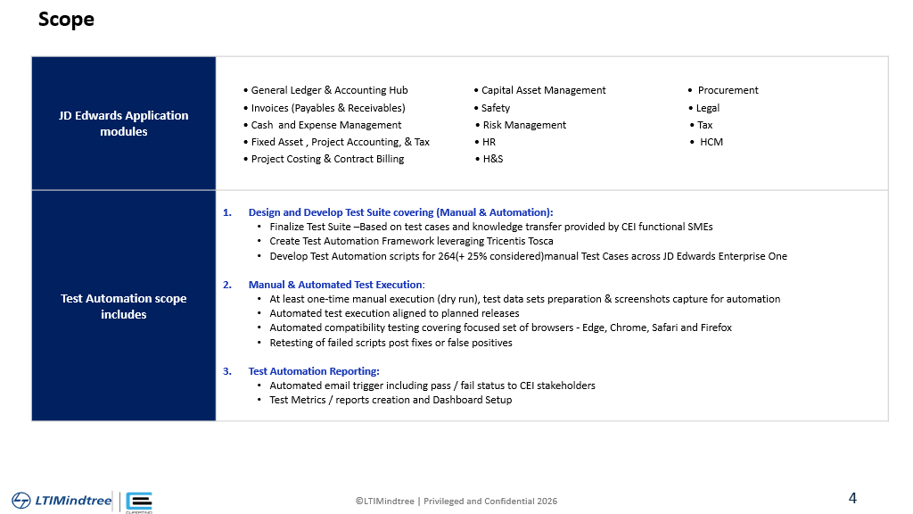

Out of scope
- Manual testing

Development Execution Strategy – Sprint Definition, MVP and complexity

LTM plans to automate CEI's JDE testing by delivering 264 automated test scripts, with an additional 25% effort allocated for medium- and high-complexity scripts. The overall script mix comprises 15% simple, 45% medium, and 40% complex scripts, to be delivered across 10 sprints of two weeks each as per below:
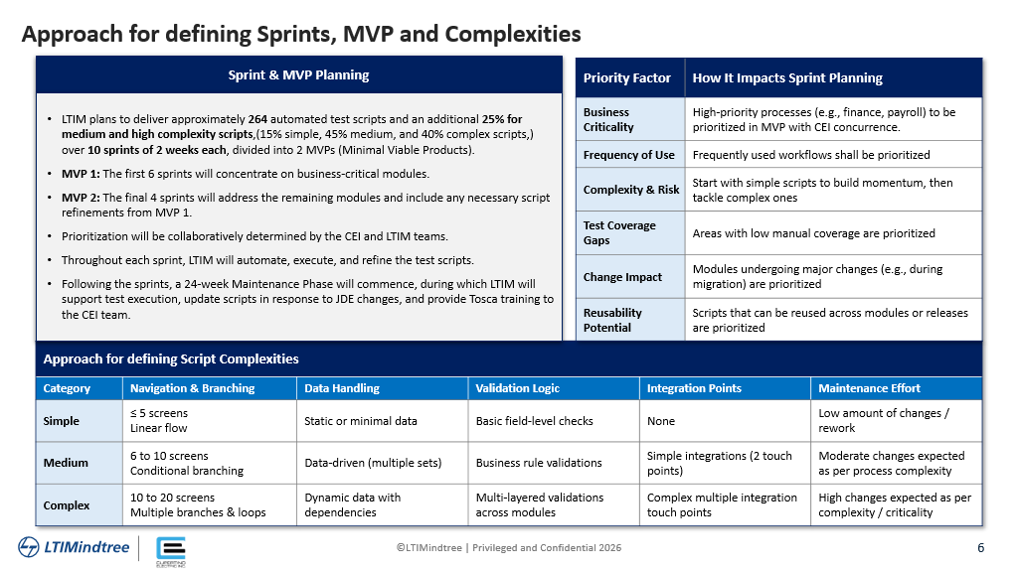
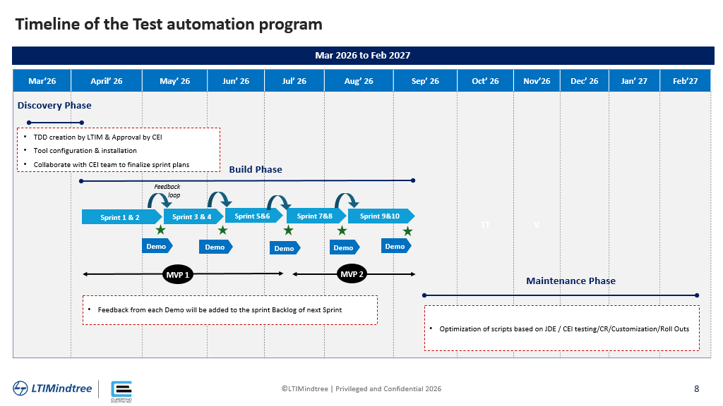

- All priorities shall be discussed between CEI, LTM & Test Automation team
- Every sprint shall constitute approximately 65 scripts with the following complexity distribution:

Complexity | Percentage
Simple | 20%
Medium | 60%
Complex | 20%

Definitions of Script complexity

Category | Navigation & Branching | Data Handling | Validation Logic | Integration Points | Maintenance Effort
Simple | Linear navigation with no branching | Single data set, minimal data manipulation | Basic field validations only | No integration with external systems | Low maintenance, minimal updates required
Medium | Conditional navigation with limited branching | Multiple data sets, moderate data manipulation | Field and form-level validations | Limited integration with internal systems | Moderate maintenance, occasional updates
Complex | Dynamic navigation with extensive branching | Complex data handling with multiple sources | Advanced validations including business rules | Integration with multiple external systems | High maintenance, frequent updates required

Guidelines for Priorities

Priority Factor | How It Impacts Sprint Planning
Business Criticality | Modules that are critical to business operations are prioritized in earlier sprints to ensure early validation.
Frequency of Use | Frequently used modules are tested earlier to reduce risk and ensure stability.
Complexity & Risk | Modules with higher complexity or risk are planned earlier to allow more time for validation and fixes.
Test Coverage Gaps | Areas with known gaps in test coverage are prioritized to improve overall quality.
Change Impact | Modules impacted by recent or upcoming changes are tested earlier to catch issues early.
Reusability Potential | Scripts that can be reused across modules or processes are prioritized to maximize ROI.

Phases, Activities and Deliverables

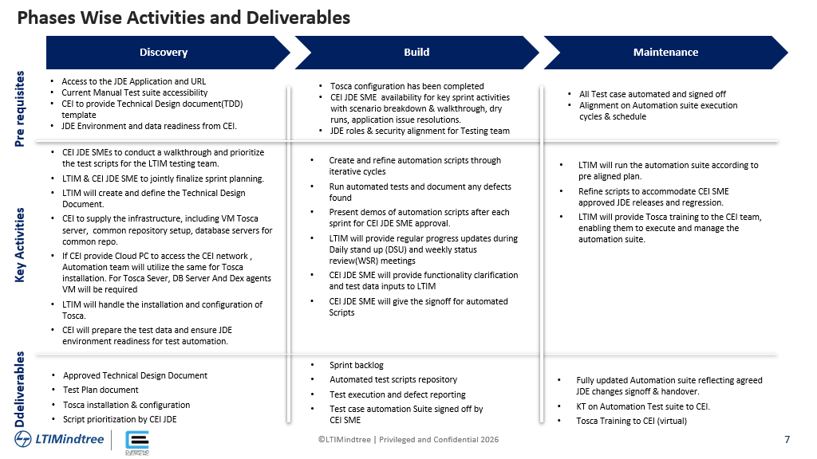
Figure 3: Project Phases, activities & deliverables

Pre- requisites and Environment Setup for Tricentis Testing tool

Activities owned by CEI

- Provisioning of VM’s for Tosca
- VM’s for Dex agents for distributed execution
- Service account roles/privileges used for the test scenario execution to be shared by CEI. These details required during the discovery phase
- MS SQL server for common repositories to work in multi-user environment (Automation script code management)
- Access to JDE environments
- All the Tricentis licenses will be owned, administered & governed by CEI

- Hardware, Software and environmental requirements
- Hardware Requirements
- CPU: i5 Dual-Core 2.4GHz
- RAM: 8 GB minimum
- Disk Space: 10 GB for standard automation
- Network: 100 Mbit/s minimum
- Software Requirements
- OS: Windows 10/11 or Windows Server 2019/2022 (64-bit)
- DB: MSSQL or Oracle for common repository setup

Activities owned by LTM

- Environment Setup
- LTM configures the following components on Azure VMs:
- Tosca License Server: Manages licenses and repositories
- Tosca Commander: Installed on VMs with access to target applications
- Tosca Agents: For distributed and parallel test execution across UI, API, and DB layers
- LTM will develop a couple of scripts to verify that the environment is functioning as expected and all accesses are proper.

Project Timeline

Project start date: April 1st, 2026
Project end date: March 31 2027

Project Reporting
The project will follow a three-tier governance framework for communication and reporting cadence.
Governance Tier | CEI Services Stakeholders | LTM Stakeholders | Agenda
Operational | - ITLT Leadership | - Program Manager  - Test Architect | - Project Status Updates review  - Defect Triage, Environmental readiness  - Immediate escalations
Managerial | - ITLT Leadership | - Account Executive  - Program Manager  - Engagement Leader | - Milestone review & trends analysis  - Risk & Issues management  - In-flight project status  - Change request review
Strategic | - ITLT Leadership | - Sector Leader  - Practice Head  - Account Executive  - Engagement manager | - Engagement Performance Review  - Key programs review  - Improvements / Value Adds

2.9 RACI

Sr # | Task | CEI | LTM
Discovery Phase
1 | Provide access to environment with licenses | R, A | C, I
2 | Provide access to Test Case repository | A | C, I
3 | Provide list of SME for validation and approval of Test Scripts | R, A | C
4 | Provision of relevant Master Data for test execution | R, A | R
5 | Finalize Script prioritization and sign-off on Sprint Plan | R, A | R
Build Phase
6 | Execute Manual Regression and Integration Test Cases | R, A | C, I
7 | Build Automated Test Scripts | C | R, A
8 | Execution of Automated Test Scripts | C, I | R, A
9 | Record and assign data or functional defects to CEI’s SME | I, R | R, A
10 | Provide functional clarification and test data inputs to LTM | R, A | R, C
11 | Schedule and monitor automation runs | I | R, A
12 | Sign off the test execution | A, R | R, C
Maintenance Phase
13 | Prioritize test scripts for execution | R, A | C
14 | Management of Master / transactional Data | R, A | C
15 | Maintenance of Automated Scripts | A | R
16 | Support on Technical issues raised for Automated scripts | A | R
17 | Continuous testing support throughout Project testing Phases | R, A | C

Assumptions

- Any Additional Automation testing beyond 25% of the agreed 264 Test scripts, LTM will do the impact analysis and share details on scope, schedule & cost impact. On mutual agreement with CEI & LTM will follow the Change request (CR) process CR process
- Any Test data masking, Data Obfuscation will follow the CR process
- Any Tosca upgrades during the project execution from current version to higher version will follow the CR route
- CEI to provide all the required software licenses and hardware required for the project

Dependencies
As per the project execution model, there would be few activities coordinated by LTM, but executed by CEI services. The activities include Development and Integrations, Testing, Database and some infrastructure aspects. Key items in each area are called out on the table below. CEI services would identify a project sponsor or a project owner who can expedite decisions and resolve dependencies with respective teams and work with LTM to ensure successful resolution.

Project Activity Area | Key Items
Development & Unit Testing of Scripts | For any limitations/issues with product information align with Tricentis and Oracle Premier Support compliance during test automation development & execution phases
Inputs from CEI | Test cases – Application knowledge
Licenses | Required Tricentis licenses will be provided by CEI
Infrastructure | - Provisioning of VM’s for Tosca  - VM’s for Dex agents for distributed execution  - Service account roles/privileges used for the test scenario execution to be shared by CEI. These details required during the discovery phase  - Database MS SQL server for common repositories to work in multiuser environment (Automation script code management)  - Access to JDE OCI environments
Test Execution | - Unit Testing of applications  - Functional testing / Integrated testing  - User acceptance testing  - Real Application ‘Database’ load Testing

Commercials

The following are the details related to pricing from LTM for this engagement:

Item | Cost (USD)
Tosca Licenses (5 users) | 59,248
Tosca Copilot | 5,060
Installation & Enablement | 25,000
Script Development (5 months) | 208,192
Stabilization (6 months) | 40,000
Total | 337,500

Licensing Terms

- Tricentis license fee will be invoiced on the day of contact execution

- Upon conclusion of the current License Resell Statement of Work, product license subscriptions will automatically renew for consecutive 12-month periods unless CEI provides a non-renewal notice at least 45 days prior to the current term's expiration. LTM will issue a renewal reminder detailing the fees and any new terms for the upcoming term at least 60 days before a term ends, effective at the beginning of the new term. LTM will also promptly inform Tricentis if CEI decides not to renew

- CEI acknowledges that the use of the Tricentis Products shall be additionally governed by the Tricentis General Terms of Use are available in Appendix 3. In connection thereto, CEI acknowledges that:
- It has familiarized itself with the usage restrictions and other obligations as detailed in the Tricentis Terms of Use.
- It shall, at all times, act in a manner consistent with the substance of these provisions; and The Tricentis Terms of Use.

Payment Milestone

- Invoices will be generated monthly as per a milestone schedule
- The invoice for the test automation project will be generated as per the milestone schedule below

Milestone Detail | Milestone | Amount (in USD)
License | On contract execution | 64,308
Tool Installation & Enablement | Month-1 | 25,000
Project Kick-off | Month-1
Implementation cost -1 | Month-3
Implementation cost -2 | Month-4
Implementation cost- 3 | Month-5
Stabilization | Month-8
Stabilization | Month-10
Total

Terms and Conditions

- The price does not include any travel expenses
- The prices are exclusive of transactional taxes such as VAT, GST etc. Applicable taxes, if any, will be charged separately over and above the invoiced amount
- If CEI services require any additional services to be provided under this SOW, the same can be managed via a change request process

Approvals

CEI Services | LTM
Signature | Signature
Signed by:  Date: | Signed by:  Date:
Title: | Title:

Annexure 1: CEI Services Compliance

LTM project and Support team is committed to comply with the following standard policies set forth by CEI Services:

1 | Data Encryption and Key Management Policy
2 | Information Systems Log Management Policy
3 | Internet Facing Systems Policy
4 | Media Handling and Disposal Policy
5 | Personnel Information Systems Usage Policy
6 | CEI Password Security Standard
7 | CEI Vulnerability Management Standard

Annexure 2: Scope Change

In the event any changes are required to the scope of the project as described or any other provisions of this SOW, such changes shall be made only in accordance with the following process:
- The Change Request shall be submitted in the form attached hereto.
- Upon receiving a Change Request, the receiving Party shall have fourteen (14) days in which to either:
- Respond in writing accepting or rejecting the change (giving written reasons for any rejection); or
- Request negotiations with the requesting Party regarding the change.
- Each Party shall act in good faith to reach an agreement in any such negotiations.
- Any changes will take effect only when incorporated in an amendment or addendum to this SOW signed by both parties.
CHANGE REQUEST FORMAT
CHANGE REQUEST
Part I – REQUEST
Reference Number | Date
Change Requested by CEI Services  LTM | Prepared By
Description of Changes

Reasons for Change

Name and Signature of Authorized Representative of Requesting Party
Part II – RESPONSE TO REQUEST
Response By CEI Services  LTM | Prepared By
Response (State the impact of the proposed changes on scope, efforts, fees, timelines, risks, and any other provisions of the WO)

Documents Requiring Amendment (Mention details of the MSA, WO and the specific clauses of those documents which require amendment)

Name and Signature of Authorized Representative of Responding Party

Annexure 3: Tricentis General Terms of Use

Effective April 18, 2024. These Terms replace and supersede all prior versions. These Tricentis General Terms of Use (these “Terms”) govern the use of the Offerings. “Customer,” “you” or “your” means the entity accepting these Terms. “Tricentis,” “Company,” “we,” “our” or “us” means the Tricentis entity identified in the Order.
Important: These Terms form a binding contract between you and Tricentis when accepted by you. You accept these Terms by (1) signing an Order referencing these Terms; (2) clicking “I accept” or “I agree” (or similar button or checkbox) to these Terms when registering for Offerings or placing an Order online; or (3) using the Offerings. These Terms are effective on the date of your acceptance. If you are accepting these Terms on behalf of an entity, you warrant and represent that you have authority to bind that entity. If you sign up for Offerings online using an email address from your employer or another entity, then you will be deemed to represent your employer or that entity and your acceptance will bind your employer or that entity to these Terms. If you do not agree to these Terms, or are not authorized to accept these Terms, you must not use the Offerings. If you accept these terms personally and not on behalf of any entity, you may not use the Offerings for or on behalf of any entity. Use of the Offerings is intended for persons eighteen (18) years of age or older. If you are between thirteen (13) and seventeen (17) years of age, you may use the Offerings under the supervision of your parent or legal guardian who has explained these Terms to you and agrees to be bound to them on your behalf. You may not use the Offerings if you are under thirteen (13) years of age.
Capitalized terms used in these Terms are defined in context or in Section 1.

- DEFINITIONS
- “Additional Terms” means additional terms that apply to certain customers and Offerings set out in Section 13.
- “Administrative Data” means account-related data collected during your purchase and use of the Offerings.
- “Affiliate“ means any individual or business entity that controls, is controlled by, or is under common control with a party where control means ownership, directly or indirectly, of 50% or more of the voting power (or equivalent).
- “Agreement” means these Terms, any applicable Additional Terms, the Order, the Ancillary Documents and, if applicable, the Data Processing Addendum.
- “Ancillary Documents” means any ancillary documents referenced in the Agreement as applicable to your ordered Offerings including the Documentation, Support Plan and Privacy Policy.
- “Customer Content” means any content, code or data provided by you or Users to us in connection with your use of, or resulting from your authorized use of, the Offerings.
- “Customer Systems” means servers, systems, platforms, networks, applications, databases, computers, mobile devices or other endpoints (physical or virtual) on which any On-Premises Product is installed, or from which SaaS Products are accessed, that are owned, operated or managed by, or on behalf of, you and your Affiliates
- “Documentation“ means the then-current official user documentation provided by Tricentis for the applicable Product.
- “Feedback” means comments, ideas, enhancement requests, recommendations, suggestions or other feedback relating to any Offerings.
- “Intellectual Property Rights” mean all registered or unregistered worldwide intellectual property rights, including copyrights, trademarks, service marks, trade secrets, patents, patent applications and moral rights.
- “Offerings” means the Products, Documentation and Professional Services that Tricentis provides to you under the Agreement.
- “On-Premises Products“ means our software products that are installed and run on Customer Systems.
- “Open-Source Software” means any software components made available or distributed with the Products that are subject to open-source licenses.
- “Order“ means the order document or online order on a form approved by Tricentis that you submit, or a Tricentis authorized reseller submits on your behalf, to Tricentis that specifies the Offerings ordered and the applicable subscription term, quantities, license metrics, fees, billing and payment terms and other terms.
- “Products“ means On-Premises Products and SaaS Products.
- “Professional Services” means professional services (excluding support) and any deliverables, as applicable, provided by Tricentis and described in the applicable Order.
- “SaaS Products“ means our hosted or cloud-based products that are provided by us on a software-as-a-service basis including any related software provided by us to access or use the product from Customer Systems.
- “Sensitive Personal Information” means an individual’s financial information, sexual orientation, political orientation, race, health or medical information protected under any health data protection laws or any other type of information protected as sensitive personal information or a special category of personal information under applicable data protection or privacy laws.
- “Service Data” means information about your and your Users’ use of the Offerings and performance of the Offerings that is anonymized and aggregated by Tricentis.
- “Support Plan” means the Tricentis support plan identified in the applicable Order.
- “Taxes” means any sales, value added, good and services, gross receipts, business and occupation, and other taxes (other than taxes on Tricentis’s income or property), export and import fees, customs duties and similar charges imposed by any government or other authority.
- “Term“ means the term specified in the Order during which Customer may use the Offerings, including any renewal terms.
- “Third-Party Content” means third-party software, products or services that are not owned by Tricentis or licensed under this Agreement that may be used or integrated with the Offerings
- “Users“ means your and your Affiliates’ employees, contractors and service providers that are authorized to use the Offerings.

- LICENSE; USE OF OFFERINGS
- On-Premises Products. For On-Premises Products specified in an Order and provided under the Agreement, Tricentis grants to you a worldwide, limited, non-exclusive, non-transferable, non-sublicensable license to install and use the On-Premises Product, in executable form, on Customer Systems and use the On-Premises Product and Documentation during the Term solely for your internal business purposes subject to the terms of the Agreement, including payment of fees.
- SaaS Products. For SaaS Products specified in an Order and provided under the Agreement, Tricentis grants to you a worldwide, limited, non-exclusive, non-transferable, non-sublicensable license to access and use the SaaS Product and Documentation during the Term solely for your internal business purposes subject to the terms of the Agreement, including payment of fees. If applicable, this includes the right to install and use any software, in executable form, that Tricentis makes available to you to access or use the SaaS Products.
- Restrictions. You and your Users must not: (1) decompile, disassemble, reverse engineer, attempt to identify source code, modify or create a derivative work of any Offerings except as expressly permitted by law (and then only with advance written notice to Tricentis); (2) copy, reproduce, republish, post or transmit any Offerings (except for archival copies, solely for backup purposes, of any software that Tricentis makes available to you for download); (3) sell, resell, rent, lease, license, sublicense, assign, distribute or transfer any Offerings to a third party except as authorized by Tricentis under a written agreement; (4) permit anyone other than Users to access and use any Offerings; (5) incorporate any Offerings into a product or service that you provide to a third party except as authorized by Tricentis under a written agreement; (6) use any Offerings to develop or operate competitive products or services; (7) publish or disclose information regarding the availability, performance or functionality of any Offerings to a third party, including any benchmarking; (8) remove, alter or obscure any proprietary rights notices contained in any Offerings; (9) use the Products in any hazardous environments in which the failure of the Products could result in death, personal injury, or physical or environmental damage; (10) attempt to gain unauthorized access to or circumvent any technical limitations on the use of any Offerings; (11) use any Offerings to store or transmit malicious code, Trojan horses, malware, spam, viruses or other destructive technology; (12) disrupt or interfere with the security, integrity or availability of any Offerings or any third parties’ use of any Offerings; (13) perform any attack, scan, test, probe or penetration other security assessment of the SaaS Products hosted in Tricentis’s third party cloud environments; (14) use any Offerings in a way that violates the terms of the Agreement, the rights of others or any applicable law; or (15) allow, encourage or assist any third party to do any of the foregoing. Any breach of this Section 2.3 will be considered a material breach.
- Limits on Use. Your use of the Products is limited to the edition, license type, quantities and metrics stated in the Order. You are responsible for all actions taken by Users or through access credentials provided by us for the Products (“User IDs”). You will notify Tricentis immediately if you become aware of any unauthorized use of the Products or a User ID. Tricentis may restrict access to features not licensed, even if made accessible at the time of delivery.
- Support. Tricentis will provide support for the Products during the Term according to the applicable Support Plan. Tricentis will not be obligated to provide support for issues arising from unauthorized use of the Products, use of the Products not in accordance with the Documentation or services for which Tricentis charges separate fees.
- Professional Services. You may purchase Professional Services under the Agreement. Professional Services are described in the applicable Order and are subject to the Professional Services Terms described in Section 13.3.
- Limited Use Licenses. At its sole discretion, Tricentis may provide certain Products to you for free or under other limited use licenses (collectively, “Limited Use Licenses”). Your use of a Product under a Limited Use License is: (1) subject to these Terms and any additional terms we specify when we provide the Limited Use License to you; and (2) restricted to the use for which it is provided during the Term. Limited Use Licenses for trials are restricted to use for internal evaluation. Limited Use Licenses for alpha, beta or other pre-release versions of Products or features are restricted to use for pre-release testing. You understand that Products and features provided under Limited Use Licenses for pre-release testing are still under development, may be inoperable or incomplete, and may contain more errors and bugs than generally available versions of Products. All information regarding the features or performance of Products provided under a Limited Use License is our Confidential Information. We may terminate a Limited Use License at any time for any reason at our sole discretion. Use of multiple free accounts to avoid incurring fees may result in termination of your account(s) or conversion to a paid subscription. Limited Use Licenses are intended for use in a nonproduction environment. Any use by you of Products under a Limited Use License, including any use in a production environment, is at your own risk. To the maximum extent permitted by law, Products under a Limited Use License are provided “AS IS” without support, warranty or indemnification of any kind, express or implied. Notwithstanding anything else in these Terms, Tricentis’s maximum aggregate liability to you for Limited Use Licenses will not exceed USD$100.
- INTELLECTUAL PROPERTY
- Tricentis Ownership. Tricentis, its Affiliates and licensors retain all right, title and interest to the Offerings (including derivative works) and all related Intellectual Property Rights. The Offerings are licensed, not sold. The use of terms such as “purchase” or “sale” will not be interpreted to imply a transfer of ownership. Your rights to the Offerings are limited to the rights expressly granted in these Terms.
- Your Ownership. You, your Affiliates and licensors retain all right, title and interest to Customer Content and all related Intellectual Property Rights. You grant to Tricentis, its Affiliates and its service providers a worldwide, limited license to use and process Customer Content during the Term solely to provide the Offerings and as expressly permitted under the Agreement. Our rights to Customer Content are limited to the rights expressly granted in these Terms.
- Feedback. If you provide Feedback to Tricentis, you agree that Tricentis may use the Feedback and incorporate the Feedback into Offerings without restriction, compensation or other obligation to you.
- Open-Source Software. A list of Open-Source Software made available or distributed with the Products is available on the Tricentis Support Portal or may be provided by Tricentis upon written request. Open-Source Software is licensed to you under its own license terms and those terms apply to your use of the Open-Source Software. In the event of a conflict, the Open-Source Software license terms supersede these Terms solely with respect to that Open-Source Software.
- Third-Party Content. Third-Party Content is licensed to you under its own terms and those terms apply to your use of the Third-Party Content. Tricentis does not control or review Third-Party Content. You are responsible for ensuring that Third-Party Content is appropriate for your intended use and that you have the rights necessary to use the Third-Party Content.
- ORDERING AND PAYMENT
- Orders. You may purchase Offerings directly from Tricentis, its Affiliates or through a Tricentis authorized reseller. The Offerings will be made available to you on your acceptance of an Order. An Order is accepted by you when you sign the Order or when you submit an online Order. The parties agree that Customer’s signature only is sufficient to create a binding contract on any unaltered order form provided by Tricentis. All Orders are non-cancelable and non-refundable except as expressly provided in these Terms.
- Reseller Orders. If you purchase through a Tricentis authorized reseller, Sections 4.4 (Fees and Payment) and 4.5 (Taxes) will not apply to that purchase and the reseller will invoice you and you will pay the reseller instead of Tricentis. If you purchase through a Tricentis authorized reseller, you agree that your order details will be as stated on the Order submitted by the reseller on your behalf and the terms of this Agreement shall apply to such Order.. You also acknowledge and agree that the reseller is not authorized to make any changes to the Agreement or make any warranties, representations, promises or commitments on behalf of Tricentis related to the Offerings. If Tricentis provides you a refund under Sections 5.1, 5.2, 6.1, 10.5 or 11.2, Tricentis will issue the refund to the reseller.
- Affiliate Orders. Your Order will be placed with the Tricentis Affiliate indicated on the Order. You may authorize your Affiliates to submit Orders under these Terms. You remain responsible for your Affiliates’ compliance with the Agreement.
- Fees and Payment. Tricentis will invoice you for fees stated on the Order after accepting your Order. Fees will be due and payable thirty (30) days after the invoice date unless the Order states a different payment due date. The fees stated in an Order are for the current versions of the Offerings and you acknowledge that you are not relying on future availability of any feature or functionality of the Offerings in consideration for the fees. If you fail to pay any amount when due under the Agreement, Tricentis may, at its sole discretion, suspend the Offerings until you pay all outstanding amounts or terminate the applicable Order or the Agreement. If Tricentis accepts your credit card for payment, you agree that Tricentis may bill your credit card or other payment method for renewals or other amounts due and payable by you under the Agreement until you provide written notice to Tricentis to stop.
- Taxes. All fees are exclusive of Taxes. You will pay or reimburse Tricentis for Taxes related to transactions under the Agreement and Tricentis will remit Taxes to the relevant taxing authorities. If you are required by applicable law to withhold and remit any amounts for payments due under the Agreement, you will inform us of the withholding amount with the Order and we will invoice you for the gross up amount so that Tricentis receives the fees due in full. Tricentis can rely on the name and address you provide to Tricentis as being the place of supply for Taxes. If you are Tax exempt, you will provide us with a copy of the exemption certificates from the relevant taxing authorities with the Order. Upon reasonable request, we will provide you documentation of payment of Taxes to the relevant taxing authorities.
- Upgrades/Downgrades. You may upgrade your account at any time. After an upgrade, we will invoice you for the additional fees due for the remainder of the applicable Term and future auto-renewals will reflect the upgrade. You may not downgrade your account during the Term.
- WARRANTIES
- Product Warranty. Tricentis warrants that the Products will materially conform to the applicable Documentation during the Term. For On-Premises Products licensed on a perpetual basis, the warranty will apply only for a period of twelve (12) months from delivery of the On-Premises Products. This warranty applies only to currently supported versions of the Product licensed to you that are used in unmodified form in accordance with the Documentation and the Agreement. If you promptly notify Tricentis of a reproducible error that Tricentis determines is a breach of this warranty, Tricentis will use commercially reasonable efforts to correct the error. If Tricentis determines that it is not commercially feasible to correct the error, Tricentis may terminate the Order for the applicable Product and refund to you the amount that Tricentis received for the unused portion of the Term after the date you notified Tricentis of the error. The remedies provided in this Section are your sole and exclusive remedies for a breach of the product © 2024 Tricentis | All Rights Reserved Tricentis General Terms of Use | Version 04/2024 | 4 warranty provided in this Section.
- Professional Services Warranty. Tricentis warrants that it will perform Professional Services under the Agreement in a professional and workmanlike manner. If you notify Tricentis of an issue that Tricentis determines is a breach of this warranty within sixty (60) days of the completion date, Tricentis will use commercially reasonable efforts to reperform the services to comply with the warranty. If Tricentis determines that it is not commercially feasible to reperform the services, Tricentis may terminate the Order for the applicable Professional Services and refund to you the amount that Tricentis received for the portion of the Professional Services that failed to conform to the warranty. The remedies provided in this Section are your sole and exclusive remedies for a breach of the professional services warranty provided in this Section.
- Warranty Disclaimer. The express warranties set forth in this Section 5 (Warranties) are in lieu of all other warranties. Tricentis makes no warranties with respect to any Open-Source Software or Third-Party Content. To the maximum extent permitted by law, Tricentis disclaims all other warranties, whether express, implied or statutory (including any implied warranties of merchantability, fitness for a particular purpose, title or noninfringement), and any warranties arising from usage of trade, course of dealing or course of performance. Tricentis does not warrant that the Offerings will meet your requirements or that they will be accurate or operate without interruption or error. You acknowledge and agree that you have not relied on any promise, warranty, or representation not expressly provided in this Agreement.
- INDEMNIFICATION
- Tricentis Indemnification. Tricentis agrees to indemnify and defend you, your Affiliates and your respective officers, directors and employees from and against any unaffiliated third-party suit or proceeding alleging that the Products infringe any patent, trademark or copyright, or misappropriate a trade secret, of that third party (“Tricentis Indemnified Claim”). Tricentis will indemnify you from the damages finally awarded against you to that third party by a court of competent jurisdiction or agreed to by Tricentis in settlement. Tricentis’s obligations under this Section 6.1 apply only if you: (1) promptly notify Tricentis of the Tricentis Indemnified Claim in writing; (2) allow Tricentis sole control over the defense of the claim and any settlement negotiations; and (3) reasonably cooperate in response to Tricentis’s requests for assistance. If a Product becomes, or in Tricentis’s opinion is likely to become, the subject of a Tricentis Indemnified Claim, Tricentis will at its option and expense either: (A) procure the rights necessary for you to make continued use of the affected Product; (B) replace or modify the affected Product to make it non-infringing while materially retaining functionality; or (C) terminate your right to use the affected Product and, upon your certified deletion of the affected Product, refund you the amount that Tricentis received for the unused portion of the Term for the terminated Product. Tricentis’s obligations under this Section 6.1 do not apply to any claim based on: (i) a combination of any Product with non-Tricentis products; (ii) any use of a Product that is not in compliance with the terms of the Agreement; (iii) continued use of an infringing version of the Product after Tricentis has provided you a non-infringing version or terminated your right to use the affected Product; (iv) any modification to a Product made by anyone other than Tricentis; (v) Customer Content; or (vi) Third-Party Content. This Section 6.1 sets forth your sole and exclusive remedy and Tricentis’s entire liability for any Tricentis Indemnified Claim.
- Customer Indemnification. You agree to indemnify and defend Tricentis, its Affiliates and their respective officers, directors and employees against any unaffiliated third-party suit or proceeding alleging that any Customer Content or our use of Customer Content in compliance with the Agreement infringes any patent, trademark or copyright, or misappropriates a trade secret, of that third party or arising out of your use of the Offerings in breach of the Agreement (“Customer Indemnified Claim”). You will indemnify Tricentis from the damages finally awarded against Tricentis to that third party by a court of competent jurisdiction or agreed to in settlement. Your obligations under this Section 6.2 apply only if Tricentis: (1) promptly notifies you of the Customer Indemnified Claim in writing; (2) allows you sole control over the defense of the claim and any settlement negotiations except that you may not agree to any settlement that requires Tricentis or its other customers to admit liability or subjects Tricentis or its other customers to ongoing obligations without Tricentis’s express prior written consent; and (3) reasonably cooperates in response to your requests for assistance. This Section 6.2 sets forth Tricentis’s sole and exclusive remedy and your entire liability for any Customer Indemnified Claim.
- LIMITATIONS OF LIABILITY
- Limitation on Damages. Neither party nor its Affiliates are liable for any lost profits or business opportunities, loss of use, loss of data, business interruption, or any indirect, punitive, special, incidental or consequential damages under any theory of liability. This limitation applies regardless of whether Tricentis or you have been advised of the possibility of those damages and regardless of whether any remedy in this Agreement fails of its essential purpose.
- Cap on Monetary Liability. The maximum aggregate liability of either party and its Affiliates for claims related to the Agreement will not exceed the fees paid or payable to Tricentis for the Offering that is subject of the claim in the 12 months preceding the event giving rise to the claim.
- Exclusions. The limitations in Section 7 (Limitations of Liability) will not apply to: (1) either party’s obligations in Section 6 (Indemnification); (2) either party’s violation of the other party’s Intellectual Property Rights; (3) your payment obligations under Section 4.4 (Fees and Payment); (4) your violation of Section 2.3 (Restrictions); or (5) any liability that cannot be excluded under applicable law.
- CONFIDENTIALITY
- Confidential Information. “Confidential Information” means non-public information provided by one party (“Discloser”) to the other party (“Recipient”) in connection with the Agreement that is labeled confidential or proprietary or that a reasonable businessperson would consider to be proprietary or confidential due to its nature. Tricentis’s Confidential Information includes information related to the Offerings, pricing and product roadmaps. Your Confidential Information includes Customer Content. Confidential Information does not include any information that Recipient can show: (1) was rightfully known to Recipient without any obligation of confidentiality at the time of disclosure; (2) was disclosed to Recipient by a third party who had the right to make the disclosure without any confidentiality restrictions; (3) was generally available to the public at the time of disclosure through no fault of Recipient; or (4) was independently developed by Recipient without use of Discloser’s Confidential Information.
- Obligations; Permitted Use and Disclosure. Recipient will protect the Discloser’s Confidential Information in the same manner as it protects its own Confidential Information of a similar nature or value, and always with at least reasonable care. Recipient may use Confidential Information of Discloser solely to exercise its rights and perform its obligations under the Agreement. Recipient may disclose Confidential Information only to its and its Affiliates’ officers, directors, employees, service providers, contractors, advisors or representatives (“Representatives") who have a reasonable need to know the Confidential Information to perform under the Agreement and who are bound by a similar duty of confidentiality. Recipient is responsible for its Representatives compliance with this Section 8. Recipient also may disclose Confidential Information to the extent required by law or regulation, in which case Recipient will notify Discloser as soon as practicable if permitted by law or regulation. At Discloser’s request and expense, Recipient will take reasonable steps to contest and to limit the scope of any required disclosure. Recipient’s obligation to protect Confidential Information of Discloser applies during the Term and for three (3) years after the end of the Term except with respect to Confidential Information that constitutes a trade secret, which will remain subject to the confidentiality obligations for as long as it remains subject to trade secret protection under applicable law.
- DATA PRIVACY AND INFORMATION SECURITY
- Data Protection and Security. Each party will comply with its respective obligations under applicable data protection laws subject to Section 9.5. Tricentis will maintain appropriate technical and organizational measures. You are solely responsible for maintaining the security of Customer Systems.
- Data Processing Addendum. If you are in the territorial scope of the General Data Protection Regulation (“GDPR”) or subject to the California Consumer Privacy Act (“CCPA”), you may sign and return the Tricentis Data Processing Addendum available at: https://www.tricentis.com/legal-information/data-processing-addendum/ (the “Data Processing Addendum”). If signed by the parties, the Data Processing Addendum is incorporated by reference to the Agreement.
- Service Data. You agree that Tricentis may analyze and use Service Data to provide features, improve the Offerings and develop new features, products and services. Service Data is not Customer Content or your Confidential Information.
- Administrative Data. You agree that Tricentis may use Administrative Data to provide the Offerings, bill you for the Offerings, advise you of new Tricentis products and services, or otherwise comply with Tricentis’s contractual obligations and applicable law. Tricentis is an independent controller of Administrative Data and will process Administrative Data under the privacy statement available at: https://www.tricentis.com/legal-information/privacy-policy/ (the “Privacy Policy”).
- Customer Content and Data Obligations. You agree to obtain and maintain all rights and permissions necessary for you to transmit Customer Content to the Products, make Customer Content, Administrative Data and Service Data available to Tricentis and its service providers in connection with your use of the Offerings, and to grant us the rights to use and process Customer Content provided under these Terms. You agree not to transmit Sensitive Personal Information to the Products or otherwise make Sensitive Personal Information available to Tricentis or its service providers in connection with the use of the Offerings unless its processing is expressly supported as a feature of the applicable Product in the applicable Documentation or a written agreement between you and Tricentis.
- TERM AND TERMINATION.
- Term. The Agreement will remain in effect for the Term of all Orders accepted under the Agreement unless earlier terminated under this Section.
- Renewals. Unless provided otherwise in your order document with a Tricentis’ authorized reseller, the Term will automatically renew for successive twelve-month terms at the same account level and quantities of the expiring Term unless otherwise stated in the Order or either party sends notice of non-renewal or downgrade at least thirty (30) days before the end of the current Term. At least sixty (60) days before the end of the current Term, Tricentis will send a renewal notice to you or your reseller, as applicable, regarding the fees and any additional terms that apply in the renewal Term, which will become effective at the start of the renewal Term unless you or your reseller timely notify us of your intent not to renew.
- Suspension. Tricentis may immediately suspend or terminate your access to the Offerings if: (1) you have not paid past-due fees; (2) Tricentis reasonably believes that you have materially breached the Agreement; or (3) Tricentis reasonably determines your use is disrupting or interfering with the security, integrity or availability of any Offerings or any third parties’ use of any Offerings.
- Termination at end of Term. Either party may terminate an Order effective at the end of the current Term by providing the other party at least thirty (30) days written notice before the end of the current Term.
- Termination for Breach. If the other party materially breaches the Agreement and does not cure the breach within thirty (30) days of receiving written notice describing the breach from the other party, the non-breaching party may terminate the affected Orders or the Agreement immediately by written notice. Termination of the Agreement under this Section will also terminate all Orders then in effect. If you terminate under this Section for Tricentis’s uncured breach, then Tricentis will refund the amount that Tricentis received for the unused portion of the Term for the terminated Offering.
- Termination for Insolvency. Either party may terminate this Agreement effective immediately by written notice if the other party becomes insolvent, makes an assignment for the benefit of creditors, or becomes subject to control of a trustee, receiver or similar authority, or to any bankruptcy or insolvency proceeding. Termination of the Agreement under this Section will also terminate all Orders then in effect.
- Effect of Expiration or Termination. Upon termination or expiration of an Order, you will immediately stop using and Tricentis will stop providing the applicable Offerings. Any unpaid fees will become immediately due and payable on termination. You will not be entitled to a refund of any pre-paid fees except as provided under Sections 5.1, 5.2, 6.1, 10.5 and 11.2.
- Survival. The following Sections will survive termination or expiration of this Agreement: 2.3 (Restrictions); 2.4 (Limits on Use); 3 (Intellectual Property); 4.4 (Fees and Payment); 5.3 (Warranty Disclaimer); 6 (Indemnification); 7 (Limitations of Liability); 8 (Confidentiality); 9 (Data Privacy and Information Security); 10.7 (Effect of Expiration or Termination; 10.8 (Survival) and 12 (General).
- MODIFICATIONS.
- Changes to Offerings. Our Offerings are continually evolving. We may update or modify the Offerings and the Ancillary Documents during the Term to reflect changes in laws, technology, industry practices, our business or other market factors. The Ancillary Documents applicable at any time are the current version. Tricentis may use third-party service providers to deliver the Offerings and may change or replace third-party service providers from time to time at its sole discretion. Use of third parties and any changes to Offerings will not materially reduce the level of performance, security or availability of the Offerings during the Term. If we decide to discontinue any Products, it will be according to our product lifecycle policies.
- Changes to Terms. We may modify these Terms (including any Additional Terms) with notice to you as provided in Section 12.6 or by posting the modified Terms on our website. Any changes to these Terms will be effective on notice for Limited Use Licenses and effective at the start of the next renewal Term for paid Offerings unless a different effective date is stated on the notice. Your continued use of the Offerings after effectiveness of the change confirms your acceptance. If the change is effective during the current Term, is not required to comply with law, and materially and adversely impacts your use of the Offerings, then you may object to the change by providing written notice to us that describes the material impact of the change to you within thirty (30) days of the date of our notice of the change. Following notice of your objection, at our option, we may: (1) delay the effective date of the change to you until after the end of the current Term; (2) use commercially reasonable efforts to remediate the impact of the change to you; or (3) terminate the affected Orders and refund to you any fees that you have pre-paid for the unused portion of the Term.

- GENERAL
- Governing Law and Forum. Unless otherwise specified in the Order, the Agreement is governed by the laws of the State of Delaware without regard to principles of conflicts of law. Any dispute arising out of the Agreement will be exclusively resolved in the State or Federal courts located in Delaware. The United Nations Convention on Contracts for the International Sale of Goods will not apply
- Arbitration. If the parties to the Agreement are located in different countries that do not have a bilateral treaty to enforce litigation, each party agrees that disputes related to this Agreement will be finally settled under the Rules of Arbitration of the International Chamber of Commerce by one or more arbitrators appointed under the Rules. The arbitration will be final and binding and the judgment on the award rendered by the arbitrator(s) may be entered in any court having jurisdiction. The place of arbitration will be where the Tricentis entity specified in the Order is located and the arbitration will be conducted in English.
- Injunctive Relief. Each party acknowledges and agrees that a breach of its obligations with respect to the other party’s Confidential Information and Intellectual Property Rights may cause irreparable harm to the other party that could not be remedied by payment of damages alone and that the other party may seek injunctive relief to prevent the breach in any appropriate jurisdiction.
- Assignment. Neither party may assign its rights or obligations under the Agreement or any Order without the prior written consent of the other party except to an Affiliate or to a successor that has acquired substantially all the business relating to the Agreement. Neither party will unreasonably withhold consent to assignment. This Agreement will bind and inure to the benefit of the parties, their respective successors and permitted assigns. Any purported assignment in violation of this Section 12.4 is void.
- Export Compliance. You agree to comply with applicable anti-corruption and export control laws in your use of the Offerings. You represent and warrant that you are not, are not acting on behalf of, and will not export or re-export any part of the Offerings to: (1) any person who is a citizen, national, resident of, or who is controlled by, the government of any country to which the United States has prohibited export transactions; (2) any person or entity listed on the U.S. Treasury Department list of Specially Designated Nationals and Blocked Persons or the U.S. Commerce Department Denied Persons List or Entity List; or (3) any country to which the United States government requires an export license or other governmental approval without first obtaining the license or approval. You are not subject, either directly or indirectly, to any order issued by any agency of the United States government revoking or denying, in whole or in part, your United States export privileges.
- Notices. All notices will be in writing. The parties agree that electronic communications will satisfy applicable legal notice requirements, including that the notice be in writing. Notice will be deemed given on the next business day after the notice is sent. Tricentis will send notices to you at the email address indicated on the Order or updated through your customer account. It is your responsibility to keep your email address for notices valid and current to receive notices. You will send termination and non-renewal notices to Tricentis at renewalbilling@tricentis.com and other notices to Tricentis at legalnotices@tricentis.com.
- Records. You agree to make available to Tricentis on request all information and records reasonably necessary to demonstrate that your use of the Offerings complies with the Agreement. For SaaS Products, you agree that Tricentis may monitor your use of the SaaS Products for compliance with applicable limits on use. If Tricentis determines your use exceeds applicable limits, Tricentis will invoice you for fees related to the excess use.
- Publicity. We may identify you as a Tricentis customer and use your name and logo in promotional and marketing materials unless you notify us that you do not consent to such use by sending notice to legalnotices@tricentis.com.
- Severability. If part of the Agreement is held to be void, invalid or unenforceable, the rest will remain in full force and effect.
- Entire Agreement. The Agreement as it may be modified from time to time is the entire agreement of the parties regarding your purchase and use of the Offerings. The Agreement supersedes all prior or contemporaneous communications, understandings and agreements, whether written or oral, between the parties regarding its subject matter. Any additional terms included in a purchase order or other business form provided by you will be for administrative purposes only, will have no legal effect and will not supersede, amend or supplement the terms of the Agreement. In the event of a conflict, the order of precedence will be: (1) the Order; (2) these Terms; and (3) the applicable Ancillary Document.
- Waiver and Amendment. The waiver of a breach of any provision of the Agreement will not constitute a waiver of another provision or a later breach. Except as provided in Section 11, any modifications to the Agreement must be in writing and signed by both parties.
- Relationship of the Parties. The parties are independent contractors. Nothing in this Agreement creates a partnership, joint venture or agency relationship. Neither party has any authority to assume or create any obligation of any kind in the name of or on behalf of the other party.
- Force Majeure. A party’s delay or failure to perform obligations under this Agreement (except for payment obligations) that is caused by conditions beyond the reasonable control of that party is not a breach of this Agreement. The time for performance will be extended for a period equal to the duration of the conditions preventing performance.
- Counterparts and Electronic Signatures. The Agreement may be executed in counterparts that will be considered one original. Electronic signatures will have the same force and effect as handwritten signatures.
- Construction. The words “include” and “including” mean “including but not limited to.” Section headings are for convenience only and are not to be used in interpreting this Agreement.
- ADDITIONAL TERMS
- U.S. Government Use (applies only if you are U.S. Federal government customer or the Agreement becomes subject to the Federal Acquisition Regulations (FAR)). You acknowledge and agree that elements of the Offerings constitute software and documentation and are provided as “Commercial Items” as defined in 48 C.F.R. 2.101 and are being licensed to you as commercial computer software subject to restricted rights described in 48 C.F.R. 2.101, 12.211 and 12.212. If acquired by or on behalf of any agency within the Department of Defense ("DOD"), the U.S. Government acquires this commercial computer software and/or commercial computer software documentation subject to the terms of the Agreement as specified in 48 C.F.R. 227.7202-3 of the DOD FAR Supplement ("DFARS") and its successors. This Section 13.1 is in lieu of, and supersedes, any other FAR, DFARS or other clause or provision that addresses government rights in computer software or technical data. Tricentis provides the Products, including related Documentation, for U.S. federal government end use solely in accordance with the following: government technical data and software rights related to the Product include only those rights customarily provided to the public as defined in the Agreement. This customary commercial license is provided in accordance with FAR 12.211 (Technical Data) and FAR 12.212 (Software) and, for Department of Defense transactions, DFAR 252.227-7015 (Technical Data – Commercial Items) and DFAR 227.7202-3 (Rights in Commercial Computer Software or Computer Software Documentation). If a government agency requests rights not granted under these terms, the parties will need to agree upon a mutually acceptable written addendum specifically granting those rights pursuant to the provisions and guidance set forth in FAR 27.405.3.
- Australian Consumer Law (applies only if you are domiciled in Australia). Nothing in the Agreement is intended to exclude, restrict or modify the application of the Australian Consumer Law as set out in Schedule 2 of the Competition and Consumer Act 2010 of Australia (“ACL”). To the fullest extent permitted by law, Tricentis’s liability for any breach of a consumer guarantee implied by the ACL (and which cannot be excluded) will be limited to any one or more of the following (as determined by Tricentis in its absolute discretion): (1) in the case of goods, the replacement repair or payment of the cost of replacement or repair of the goods; and (2) in the case of services, supplying the services again or payment of the cost of having the services supplied again.
- Professional Services Terms (applies only to Professional Services purchased under the Agreement). If you are purchasing Professional Services under the Agreement, the Professional Services Terms available at: https://www.tricentis.com/legalinformation/professional-services-terms/ (the “Professional Service Terms”) apply, supplement these Terms and supersede any conflicting terms in these Terms.
- Product-Specific Terms (apply only to certain Products purchased under the Agreement). If you are purchasing any of the Products listed below, the Product-specific terms linked below apply, supplement and supersede any conflicting terms in these Terms or a signed agreement between the parties.

Tosca Connect | https://www.tricentis.com/legal-information/tosca-qtest-connect-terms/
qTest Connect | https://www.tricentis.com/legal-information/tosca-qtest-connect-terms/
Testim | https://www.tricentis.com/legal-information/testim-terms/
TestProject | https://www.tricentis.com/legal-information/testproject-terms/
Tricentis AI Solutions | https://www.tricentis.com/legal-information/ai-terms



